PROJECTDEVELOPMENTDELIVERYOFSPRINT-2

|  |  |
| --- | --- |
| TEAMID | PNT2022TMID49411 |
| PROJECTNAME | SMARTSOLUTIONSFORRAILWAYS |

Proposedarchitectureforsmarttrackmonitoringsystem.

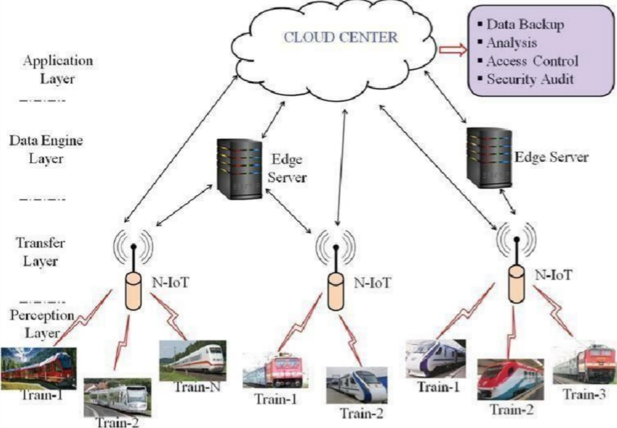

StructuralhealthmonitoringofrailwaytracksusingIOT-basedmultirobotsystem:

